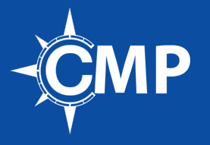
Fonts
The Charter Companies recommends use of the following fonts to make your resume ATS (applicant tracking system) compliant. Here is why: most pre-screening has been automated by using bots to screen against preset criterion. Some fonts are more easily recognized than others by these bots. We know that there are resumes that get screened out because their fonts are not read correctly. In this matter, it pays to play to what works.
- Palatino
- Georgia
- Garamond
- Cambria
- Helvetica
- Calibri
- Verdana
- Tahoma
- Arial

Note: We recommend having both a PDF and .doc or .doc version of your resume. PDF’s are not always read by an ATS.
When sending your resume to a recruiter we recommend that you send it in a PDF. The reason is, if a recruiter wants to make a change to your resume you want them to request a word document or let them know you will make the changes. You want to control how many versions of your resume are being created.
A simple way to ensure that your resume will be read by a bot is to convert it to a plain-text file. If anything in your plain-text version is out of sorts, that’s how it will be read. Make your changes and re-test.

