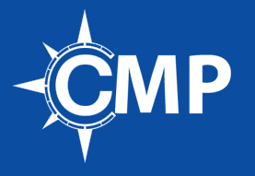

**Assessment Guide to follow when you are looking at colleges**

The Career Management Platform is looking for you to ask these questions. We want you to look at choosing an institution is a **MASSIVE** investment and you want to make the best investment possible. If you are looking for a strong ROI *(return on investment)* questions six on are **VERY** important. As a college professional enters into their Freshman year their building process starts. Building a powerful network is imperative in landing internships. If a school does not have a strong handle on question six on, we suggest running the LinkedIn search on the Alumni Network. Choosing the best institution that will bring you the largest ROI is not judged on the dorms or how awesome the campus looks; it comes down to the relationship the institution has with their alumni and the companies that they are affiliated with for internship.

Our College All Access Membership coaches, mentors and guides college students on developing a plan to execute, building a powerful network, landing multiple internships and being able to represent their brand while in college. So, pick the best one for you and we will guide you on how to leverage the data to give you the best advantage for your investment.

1. Majors offered
2. Class sizes
3. Campus
4. Dorms
5. Aesthetics
6. What is the size of your Alumni network?
7. Career Service Professionals to student ratio
8. What companies does the College or University partner with for internship (get the list)?
9. Internship ratio for Sophomore year students
10. Internship ratio for Junior year students
11. Internship ratio for Seniors attending a 5th year
12. Ratio of college seniors who receive offers prior to graduation
13. How many career events does the College or University host each year?